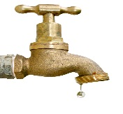
Bee Branch Water Association
P.O. Box 180
Bee Branch, AR 72013
501-654-2292

New Service

Name _____________________

Mailing Address _________________________ City ________________

Zip Code ______________________

Service Address (if different from mailing) ____________________________

Phone Number____________________________

Driver’s License ____________________________

We need a copy of driver’s license

Can not be done by credit or debit cards
Two separate checks
Or
Money order
cash

Renters deposit is $200.00 plus a $40.00 service charge

Owner must have copy of purchase of property through bank
deposit $150.00 and $40.00 service charge

once meter deposit is paid we can schedule time for installing meter

