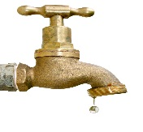
Bee Branch Water Association
P.O. Box 180
Bee Branch, AR 72013
501-654-2292

__________Yes, I’m in favor of the Reconstitution of the Corporation into Bee Branch Water Public Water Authority.

___________No, I’m not in favor of Reconstitution of Corporation into Bee Branch Water Public Water Authority.

___________________ ________________________________
Date Signature
This will change Bee Branch Water Association to Bee Branch Water Public Authority allowing us to qualify for grants.

Refold showing return address and stamp permit and drop in the mail. Postage was paid by Bee Branch Water.
Thank You

